* 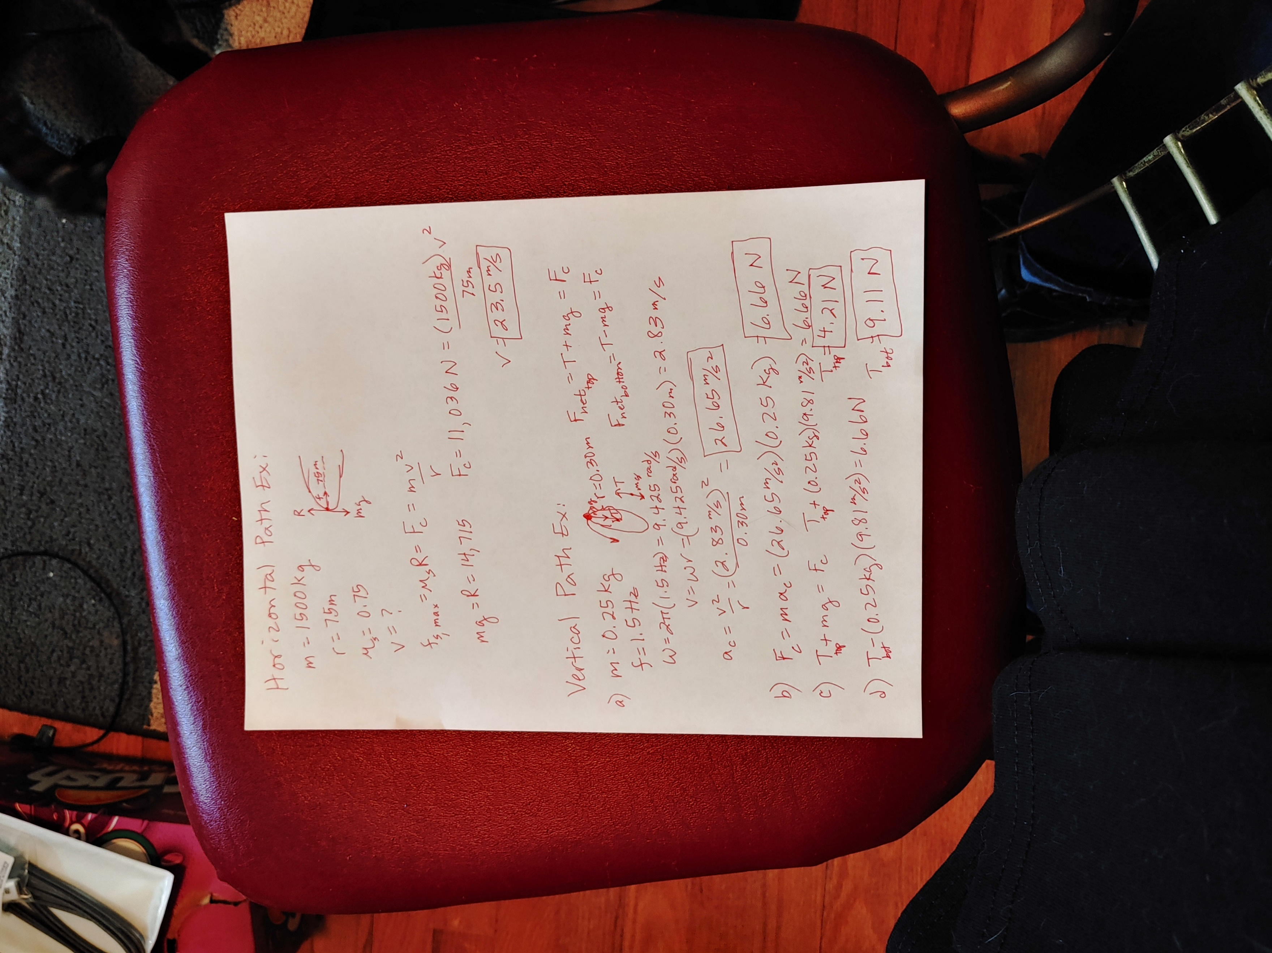**Horizontal circular path:**
* **A 1500 kg car travels around a 75 m radius curve in the road. If the coefficient of static friction between the tires and the road is 0.75, what is the maximum speed the driver can go around this curve without slipping?**
* **Vertical circular path:**
* **A 0.25 kg pebble is placed in a 0.30 m long sling and rotated in a vertical circle with a frequency of 1.5 Hz.**
* **What is the centripetal acceleration?**
* **What is the centripetal force?**
* 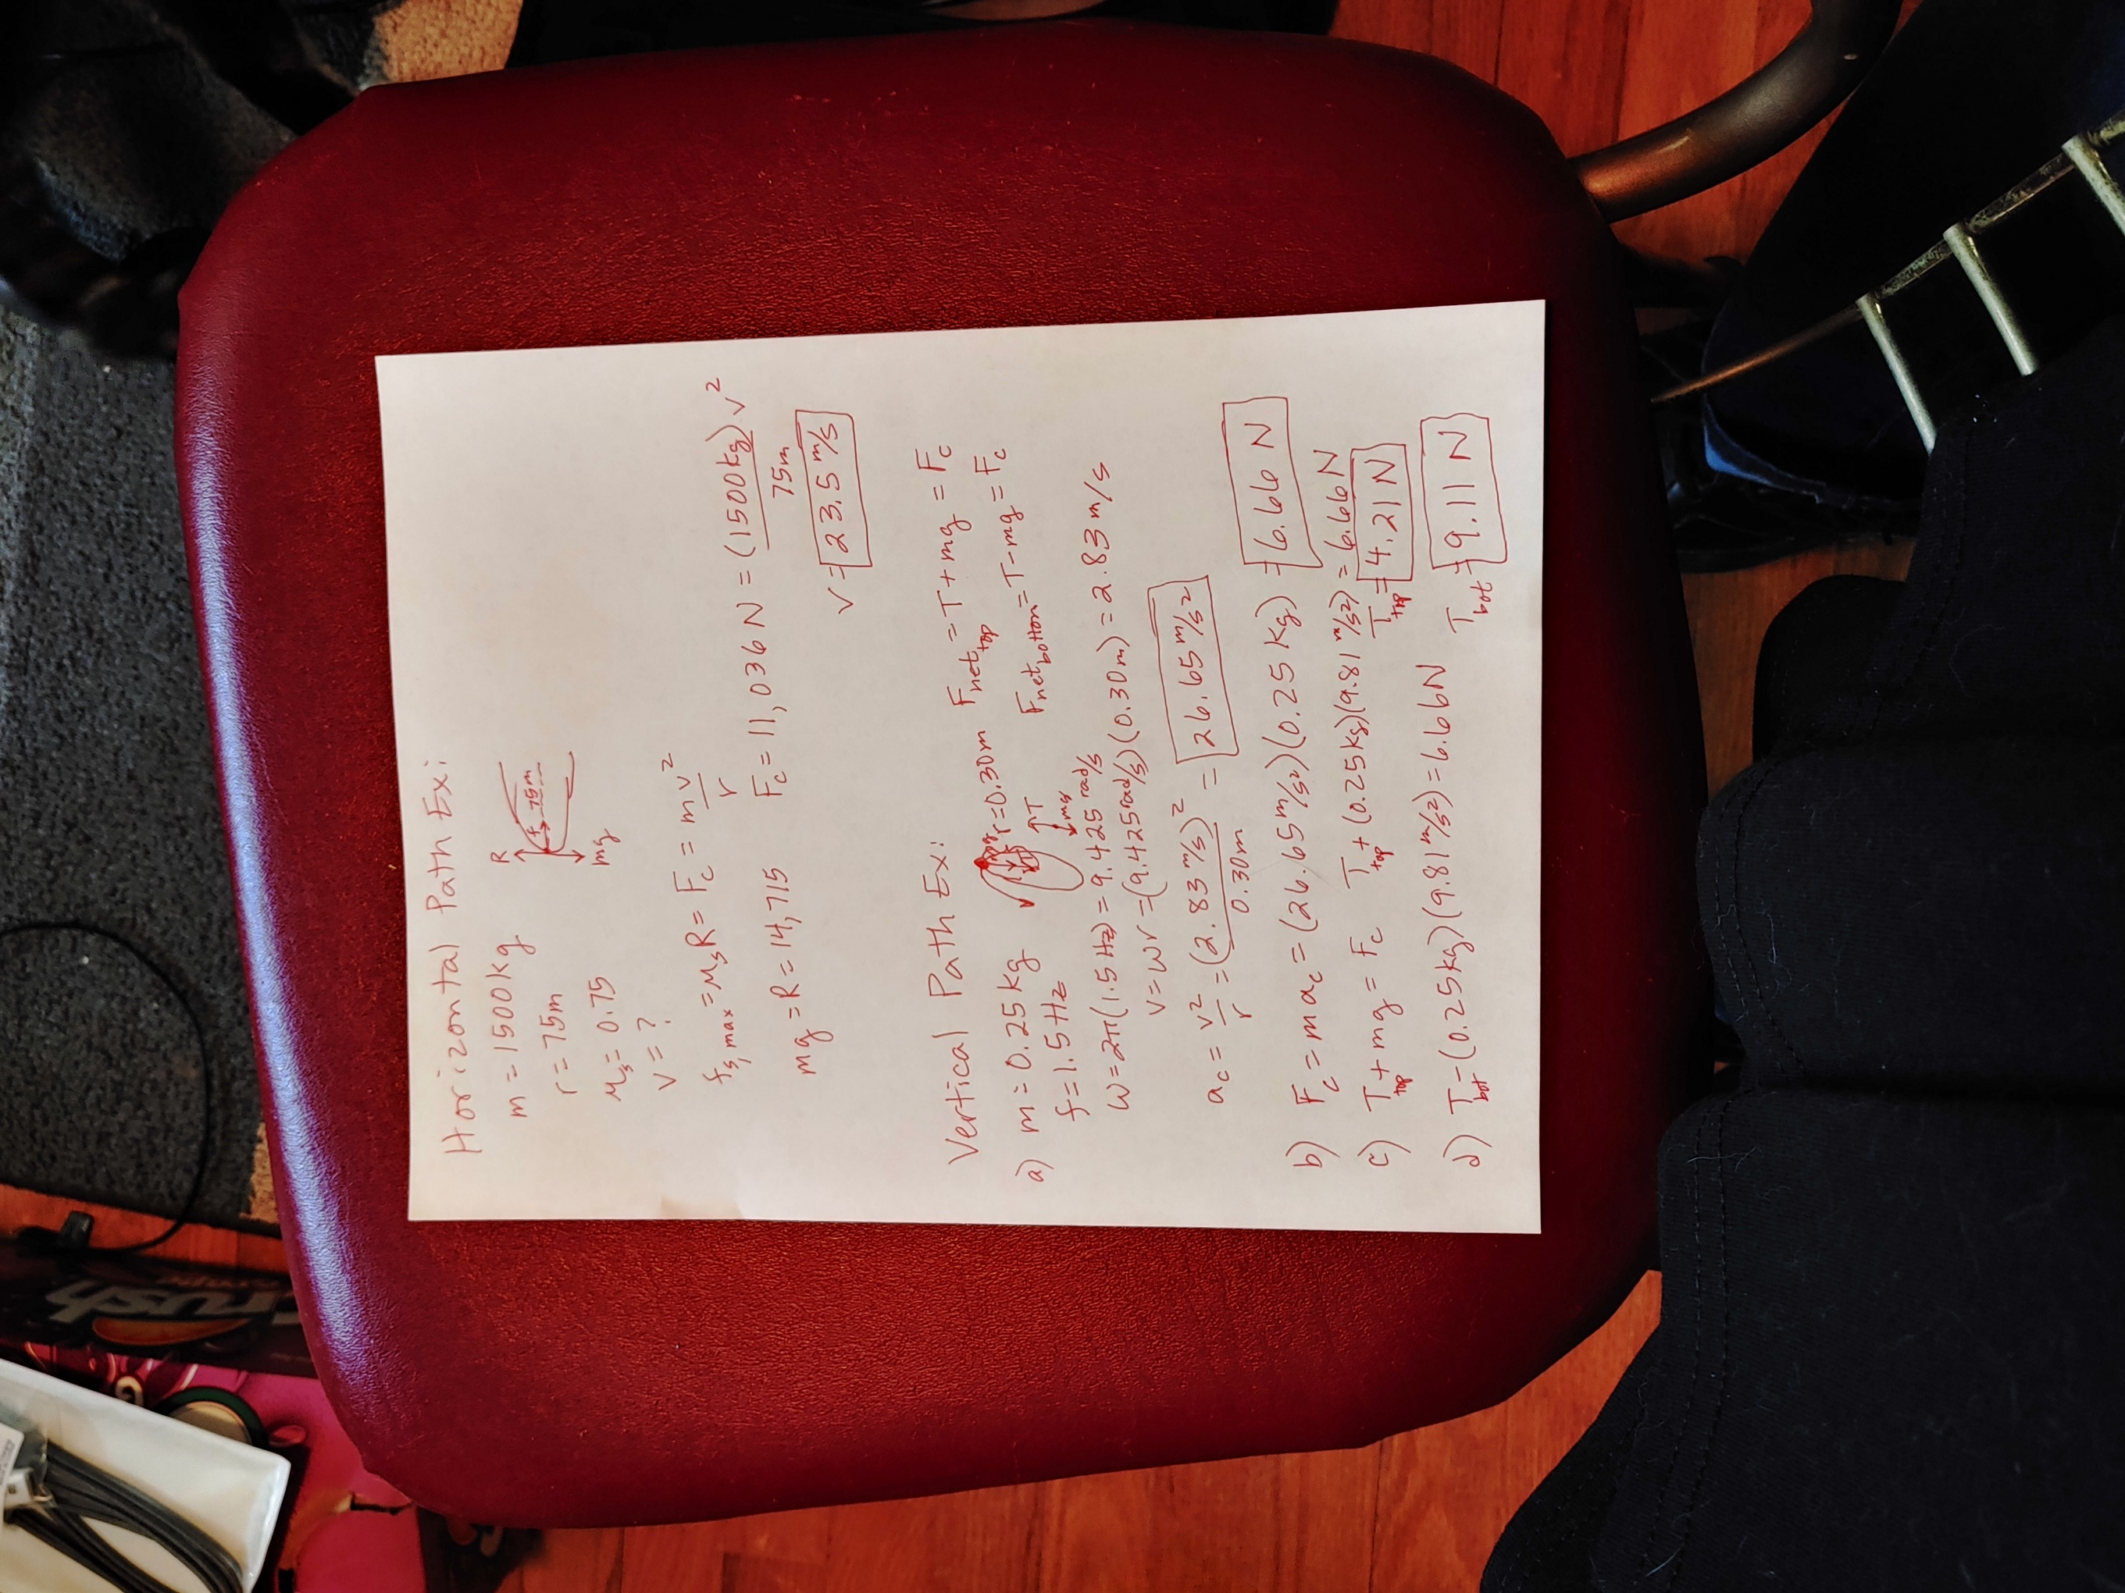**What is the tension in the sling at the top of the circle?**
* **What is the tension in the sling at the bottom of the circle?**
* **Banked curve:**
* **A 1500 kg car travels around a 75 m radius curve in the road. If the coefficient of static friction between the tires and the road is 0.75, what is the maximum speed the driver can go around this curve without slipping if the roadbed is banked at 20?**

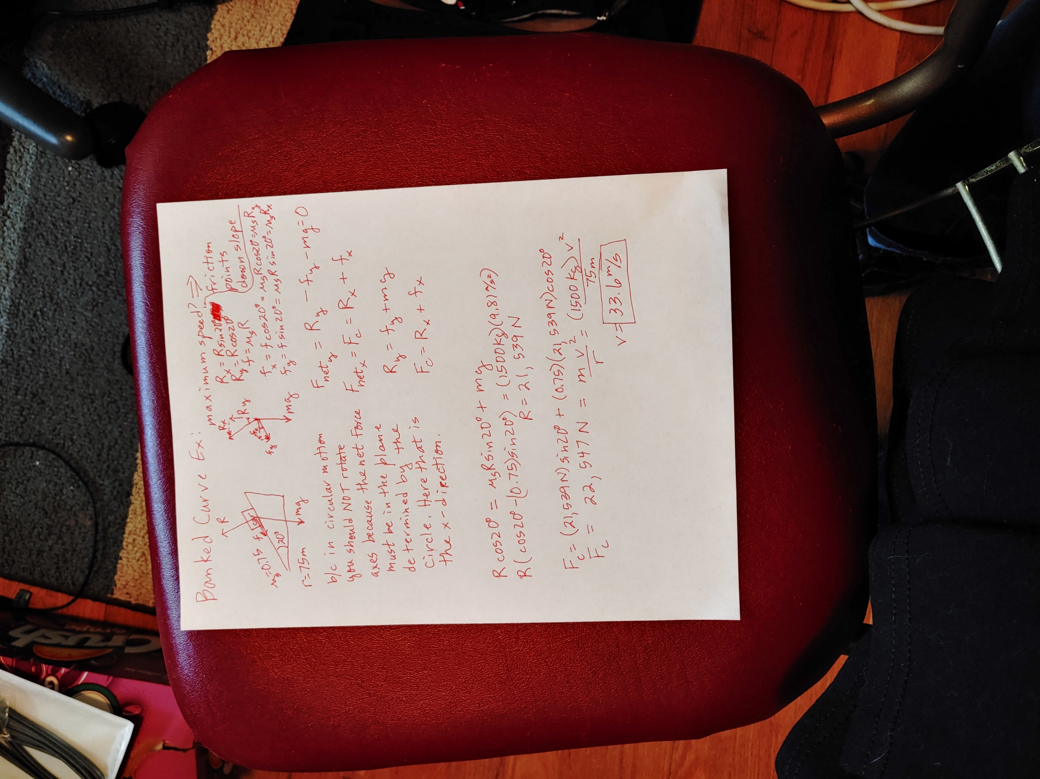

* **If the road surface gets icy, and approximates a frictionless surface, how fast can the driver go around the banked curve?**